HOW TO USE THE WEBSITE: CLUSTER PORTAL OF AHVY SCHEME

There are about 25,064 Products in the web portal which are put under 25 different Product categories and then they are bifurcated into different Sub categories.
Then the products are even put under 32 different Crafts where one can go through Craft Gallery.
To start with:
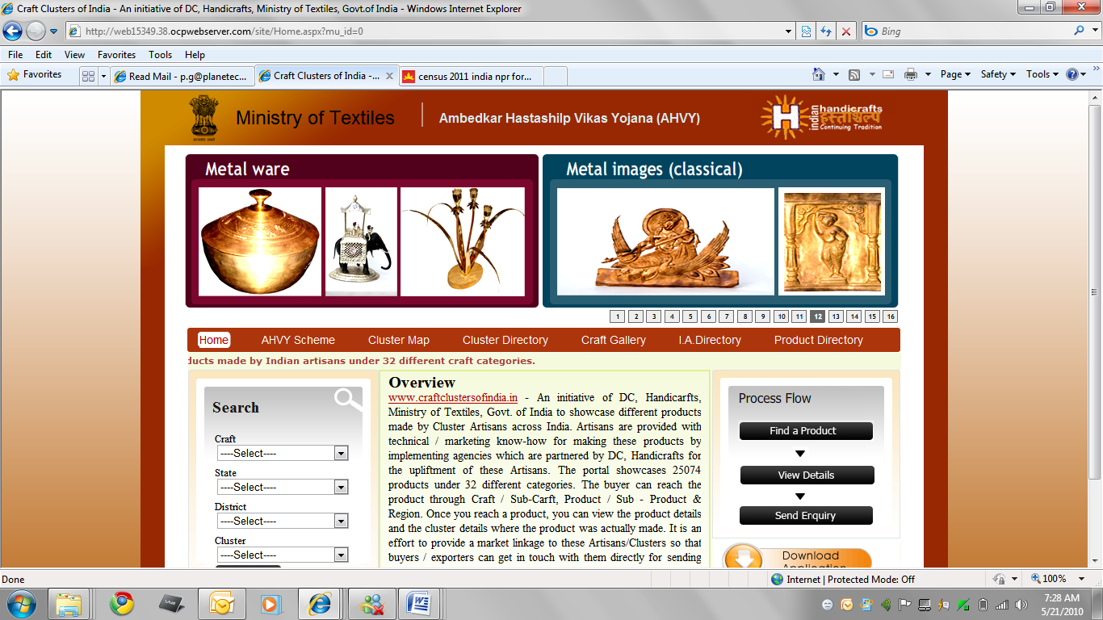
Click on Product Directory
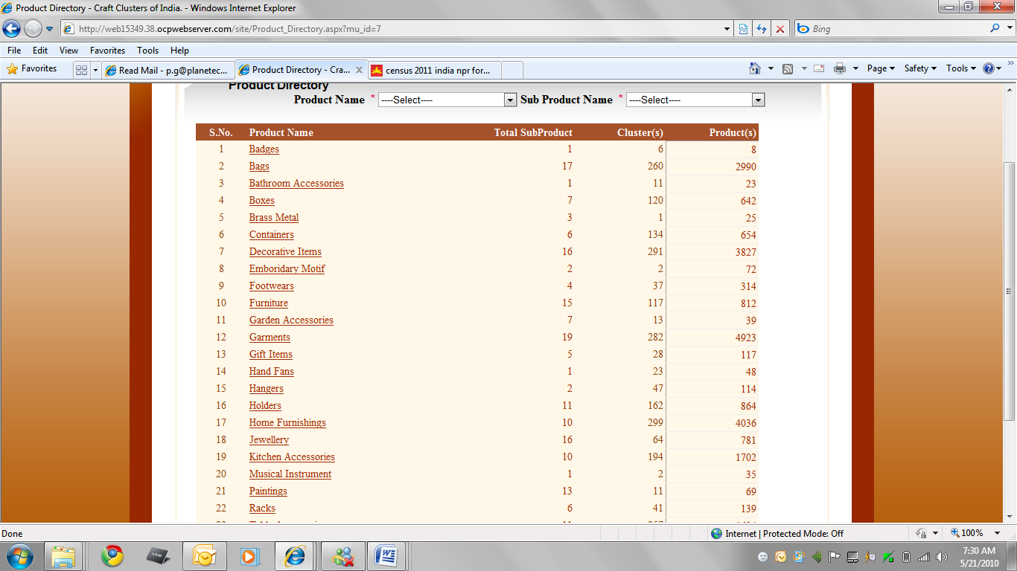
Click on any Product Category
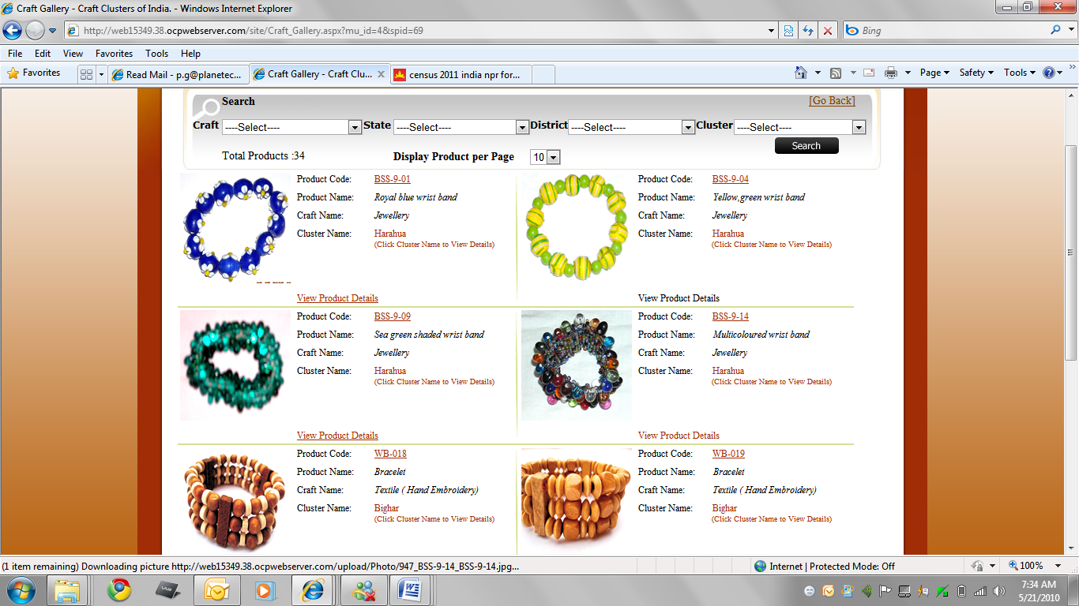
Click on the Product code to send the Query
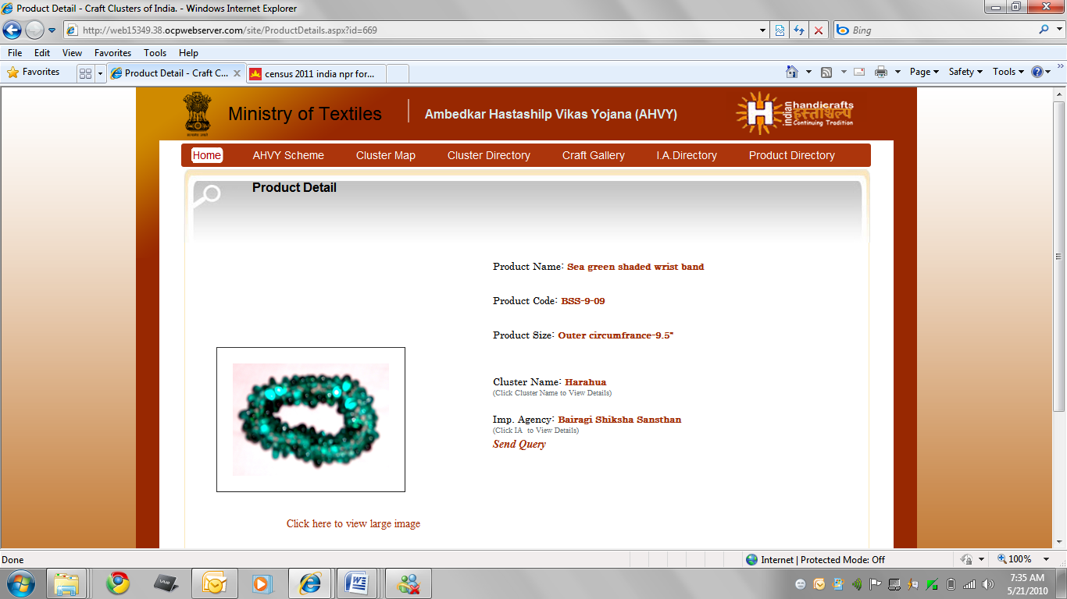
Click on Send Query
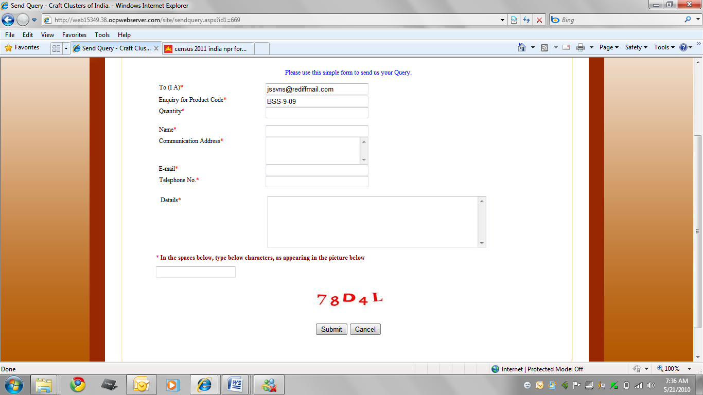
Then a form to be filled which would be directly sent to Implementing Agency under which a particular cluster is working.
Click on Submit and enquiry would be sent.

We can even go through Craft Gallery
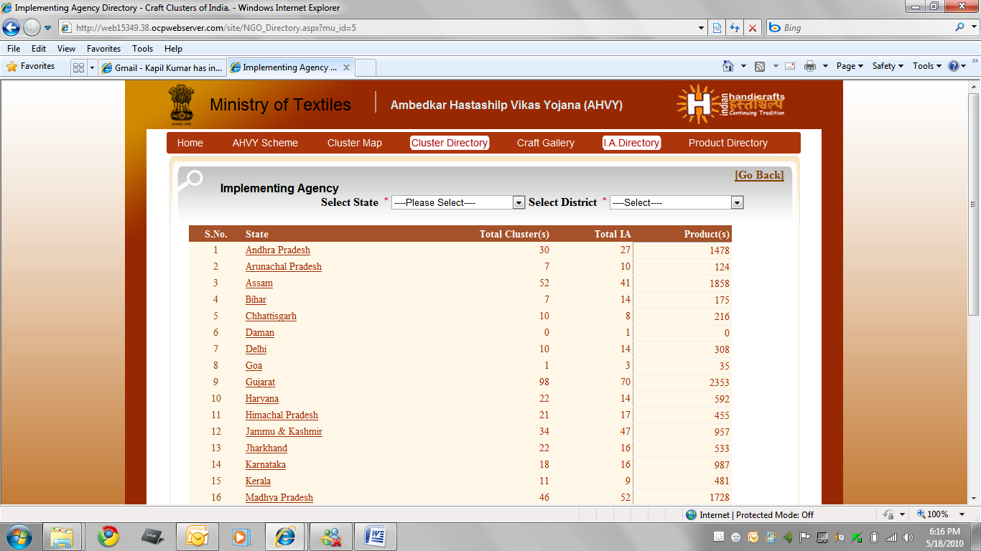
Click on Craft Gallery
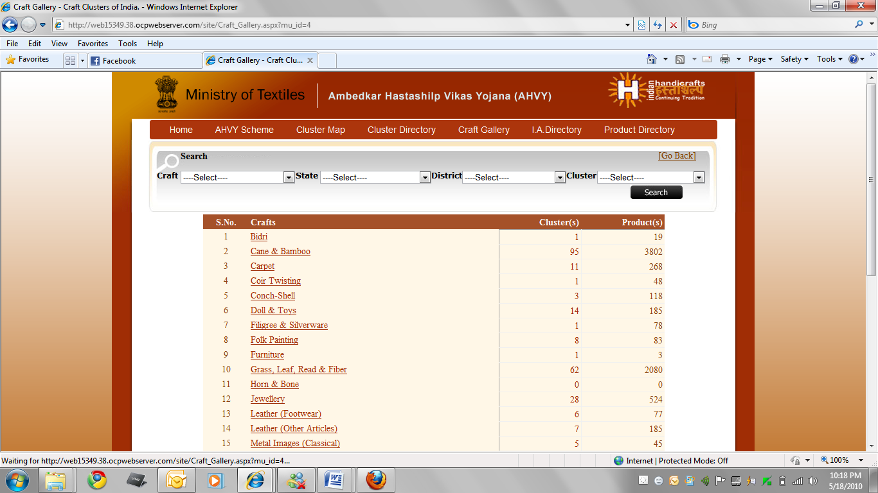
Click on Bidri craft
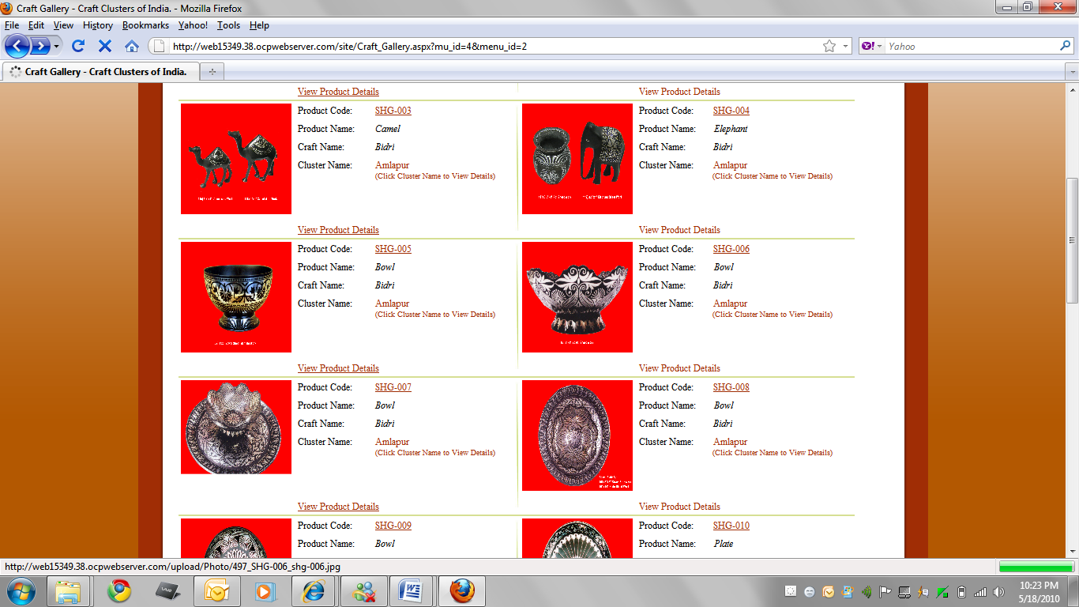
Click on Product code and then the same procedure.
Go to Implementing Agency Directory:
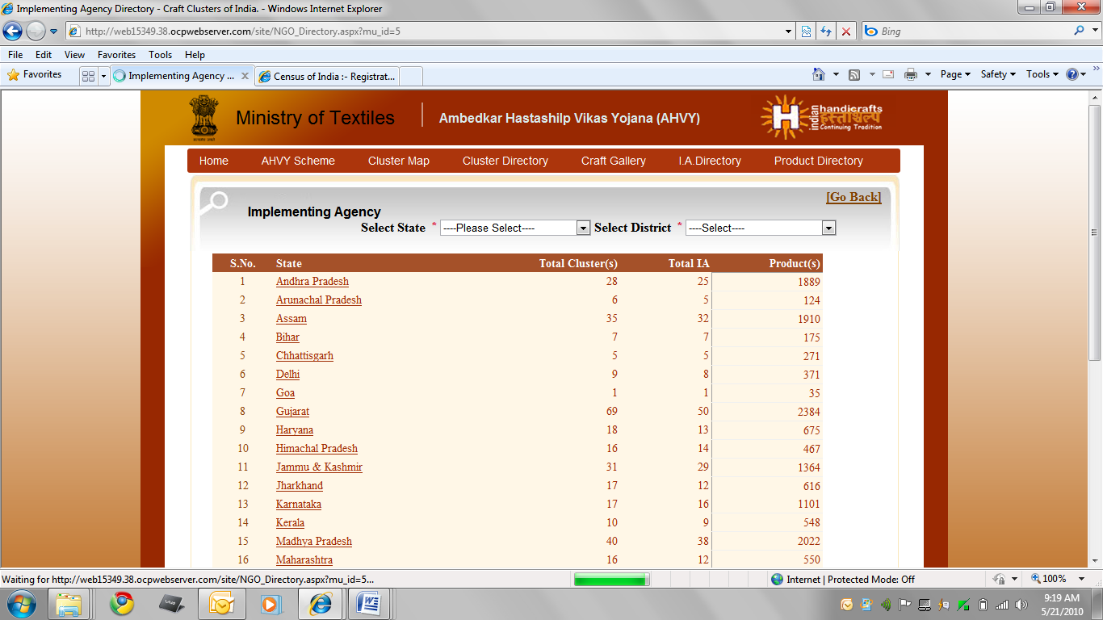
Click on any state.
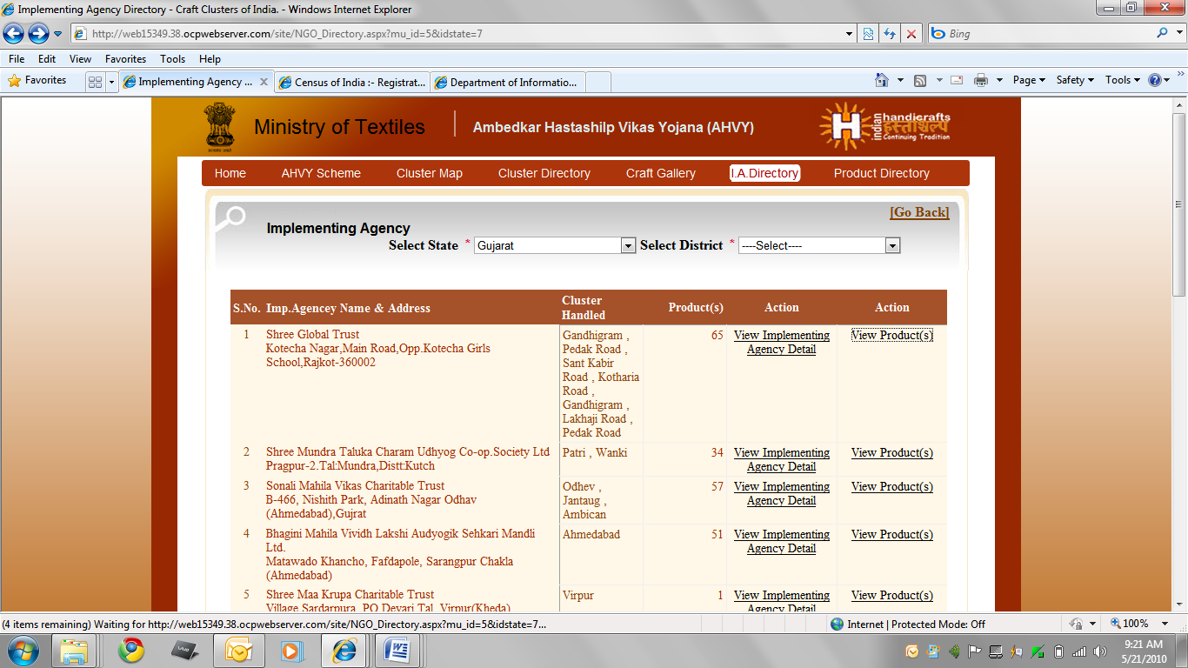
Click on IA name
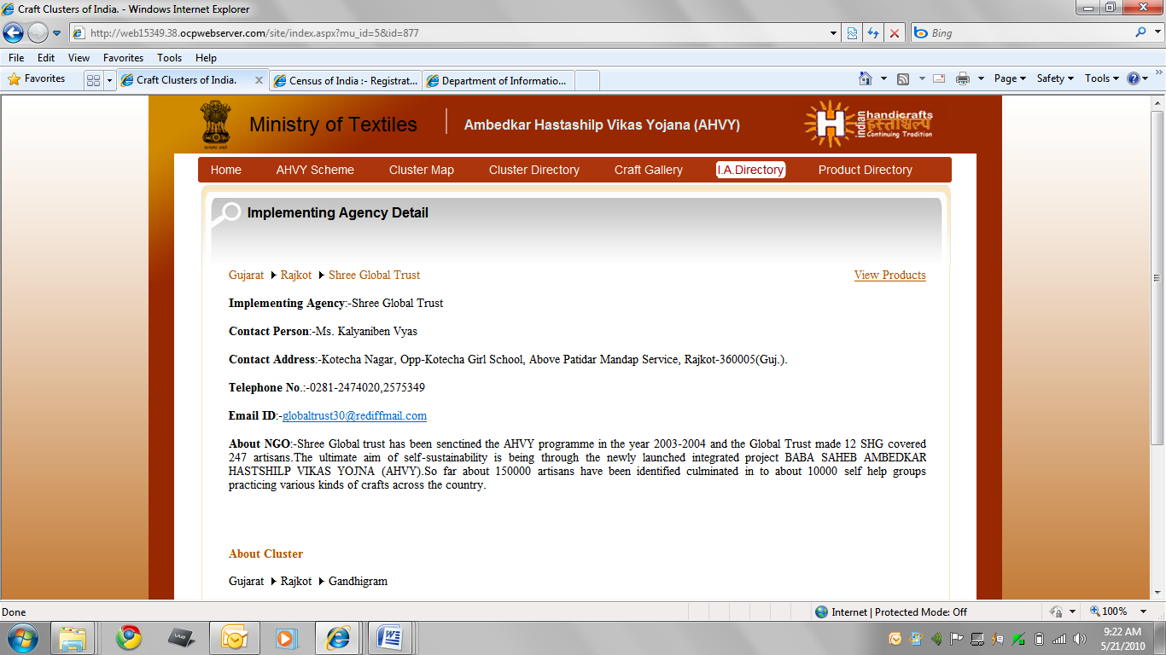
Click on View product
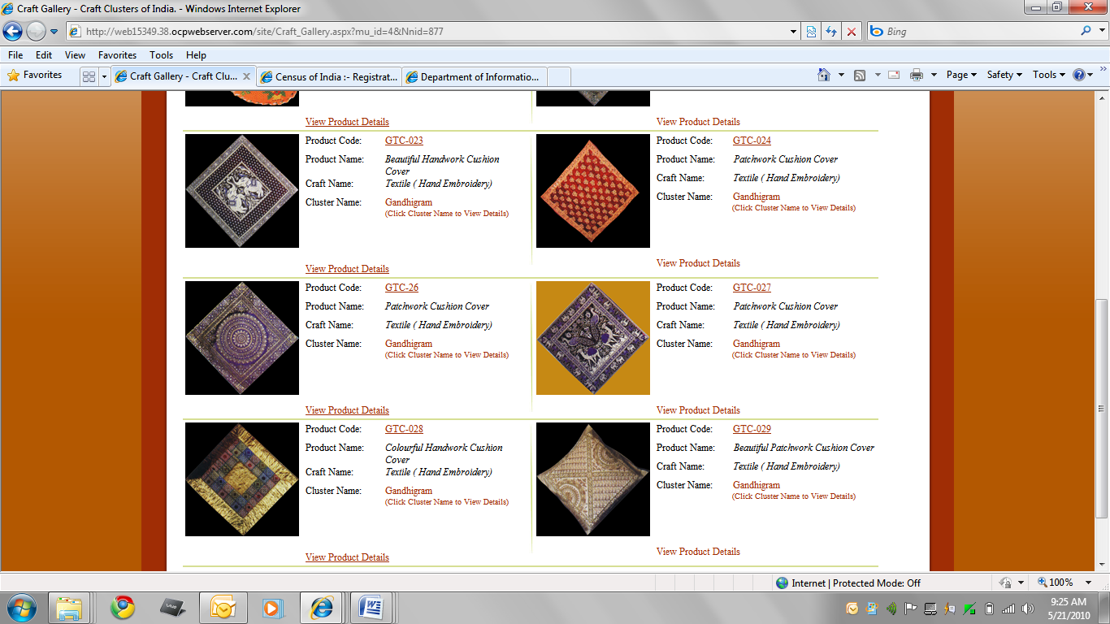
Click on Product code and send the query with the same procedure as mentioned above.

